Introduction to Dimensionality Reduction
Introduction to Dimensionality Reduction - GeeksforGeeks
https://www.geeksforgeeks.org/machine-learning/dimensionality-reduction/

When working with machine learning models, datasets with too many features can cause issues like slow computation and overfitting. Dimensionality reduction helps to reduce the number of features while retaining key information. Techniques like principal component analysis (PCA), singular value decomposition (SVD) and linear discriminant analysis (LDA) convert data into a lower-dimensional space while preserving important details.
Example: when you are building a model to predict house prices with features like bedrooms, square footage and location. If you add too many features such as room condition or flooring type, the dataset becomes large and complex.
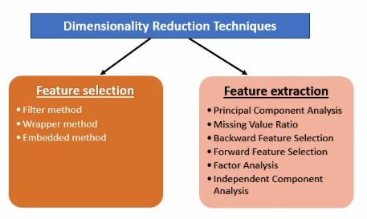
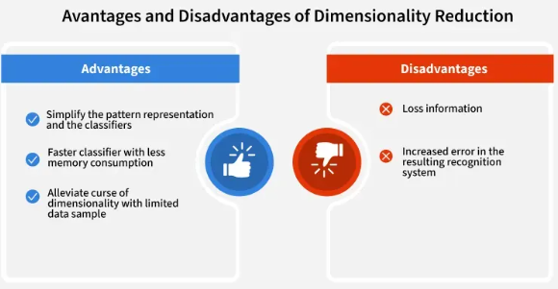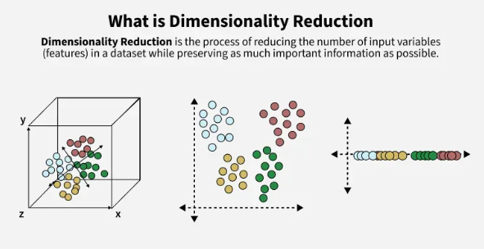
How Dimensionality Reduction Works?
Lets understand how dimensionality Reduction is used with the help of example. Imagine a dataset where each data point exists in a 3D space defined by axes X, Y and Z. If most of the data variance occurs along X and Y then the Z-dimension may contribute very little to understanding the structure of the data.
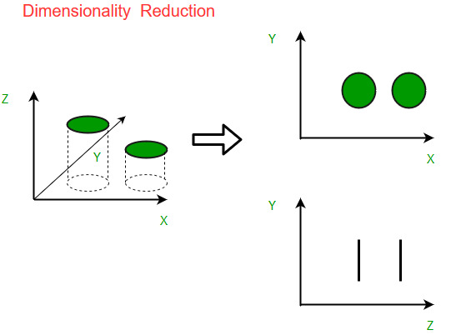
- Before Reduction You can see that Data exist in 3D (X,Y,Z). It has high redundancy and Z contributes little meaningful information
- On the right after reducing the dimensionality the data is represented in lower-dimensional spaces. The top plot (X-Y) maintains the meaningful structure while the bottom plot (Z-Y) shows that the Z-dimension contributed little useful information.
This process makes data analysis more efficient, improving computation speed and visualization while minimizing redundancy

Dimensionality Reduction Techniques
Dimensionality reduction techniques can be broadly divided into two categories:
1. Feature Selection
Feature selection chooses the most relevant features from the dataset without altering them. It helps remove redundant or irrelevant features, improving model efficiency. Some common methods are:
- Filter methods rank the features based on their relevance to the target variable.
- Wrapper methods use the model performance as the criteria for selecting features.
- Embedded methods combine feature selection with the model training process.
Please refer to Feature Selection Techniques for better in depth understanding about the techniques.

2. Feature Extraction ( i.e Derived Metrics)
Feature extraction involves creating new features by combining or transforming the original features. These new features retain most of the dataset’s important information in fewer dimensions. Common feature extraction methods are:
- Principal Component Analysis (PCA): Converts correlated variables into uncorrelated 'principal components, reducing dimensionality while maintaining as much variance as possible enabling more efficient analysis.
- Missing Value Ratio: Variables with missing data beyond a set threshold are removed, improving dataset reliability.
- Backward Feature Elimination: Starts with all features and removes the least significant ones in each iteration. The process continues until only the most impactful features remain, optimizing model performance.
- Forward Feature Selection: Forward Feature Selection Begins with one feature, adds others incrementally and keeps those improving model performance.
- Random Forest: Random forest Uses decision trees to evaluate feature importance, automatically selecting the most relevant features without the need for manual coding, enhancing model accuracy.
- Factor Analysis: Groups variables by correlation and keeps the most relevant ones for further analysis.
- Independent Component Analysis (ICA): Identifies statistically independent components, ideal for applications like ‘blind source separation’ where traditional correlation-based methods fall short.

Dimensionality Reduction Real World Examples
Dimensionality reduction plays a important role in many real-world applications such as text categorization, image retrieval, gene expression analysis and more. Here are a few examples:
- Text Categorization: With vast amounts of online data dimensionality reduction helps classify text documents into predefined categories by reducing the feature space like word or phrase features while maintaining accuracy.
- Image Retrieval: As image data grows indexing based on visual content like color, texture, shape rather than just text descriptions has become essential. This allows for better retrieval of images from large databases.
- Gene Expression Analysis: Dimensionality reduction accelerates gene expression analysis help to classify samples like leukemia by identifying key features, improve both speed and accuracy.
- Intrusion Detection: In cybersecurity dimensionality reduction helps analyze user activity patterns to detect suspicious behaviors and intrusions by identifying optimal features for network monitoring.
Advantages of Dimensionality Reduction
As seen earlier high dimensionality makes models inefficient. Let's now summarize the key advantages of reducing dimensionality.
- Faster Computation: With fewer features machine learning algorithms can process data more quickly. This results in faster model training and testing which is particularly useful when working with large datasets.
- Better Visualization: As we saw in the earlier figure reducing dimensions makes it easier to visualize data and reveal hidden patterns.
- Prevent Overfitting: With few features models are less likely to memorize the training data and overfit. This helps the model generalize better to new, unseen data improve its ability to make accurate predictions.
Disadvantages of Dimensionality Reduction
- Data Loss & Reduced Accuracy: Some important information may be lost during dimensionality reduction and affect model performance.
- Choosing the Right Components: Deciding how many dimensions to keep is difficult as keeping too few may lose valuable information while keeping too many can led to overfitting.

Feature Selection Techniques in Machine Learning
In data science many times we encounter vast of features present in a dataset. But it is not necessary all features contribute equally in prediction that's where feature selection comes. It involves selecting a subset of relevant features from the original feature set to reduce the feature space while improving the model’s performance by reducing computational power. When a dataset has too many features, some may be irrelevant or add noise which can slow down training process and reduce accuracy but it helps in building simpler, faster and more accurate models and also helps in reducing overfitting.
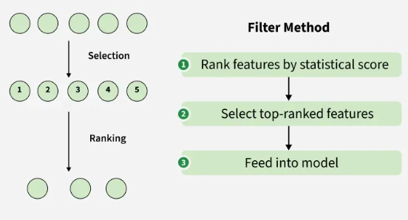

There are various algorithms used for feature selection and are grouped into three main categories and each one has its own strengths and trade-offs depending on the use case.
1. Filter Methods
Filter methods evaluate each feature independently with target variable. Feature with high correlation with target variable are selected as it means this feature has some relation and can help us in making predictions. These methods are used in the preprocessing phase to remove irrelevant or redundant features based on statistical tests (correlation) or other criteria.
Advantages:
- Quickly evaluate features without training the model.
- Good for removing redundant or correlated features.
Limitations: These methods don't consider feature interactions so they may miss feature combinations that improve model performance.
Some techniques used are:
Some techniques used are:
- Information Gain: It is defined as the amount of information provided by the feature for identifying the target value and measures reduction in the entropy values. Information gain of each attribute is calculated considering the target values for feature selection.
- Chi-square test: It is generally used to test the relationship between categorical variables. It compares the observed values from different attributes of the dataset to its expected value.
- Fisher’s Score: It selects each feature independently according to their scores under Fisher criterion leading to a suboptimal set of features. The larger the Fisher’s score is, the better is the selected feature.
- Pearson’s Correlation Coefficient: It is a measure of quantifying the association between the two continuous variables and the direction of the relationship with its values ranging from -1 to 1.
- Variance Threshold: It is an approach where all features are removed whose variance doesn’t meet the specific threshold. By default this method removes features having zero variance. The assumption made using this method is higher variance features are likely to contain more information.
- Mean Absolute Difference: It is a method is similar to variance threshold method but the difference is there is no square in this method. This method calculates the mean absolute difference from the mean value.
- Dispersion ratio: It is defined as the ratio of the Arithmetic mean (AM) to that of Geometric mean (GM) for a given feature. Its value ranges from +1 to infinity as AM ≥ GM for a given feature. Higher dispersion ratio implies a more relevant feature.
- 2. Wrapper methods

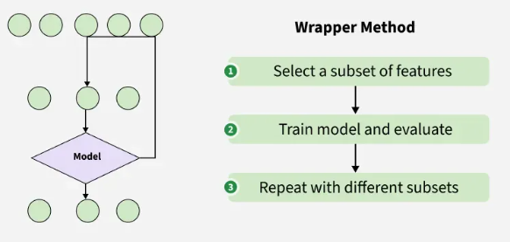
Wrapper methods are also referred as greedy algorithms that train algorithm. They use different combination of features and compute relation between these subset features and target variable and based on conclusion addition and removal of features are done. Stopping criteria for selecting the best subset are usually pre-defined by the person training the model such as when the performance of the model decreases or a specific number of features are achieved.
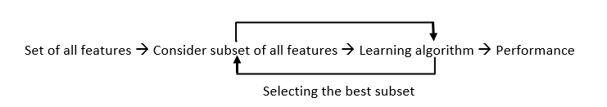
Advantages:
- Can lead to better model performance since they evaluate feature subsets in the context of the model.
- They can capture feature dependencies and interactions.
Limitations: They are computationally more expensive than filter methods especially for large datasets.
Some techniques used are:
- Forward selection: This method is an iterative approach where we initially start with an empty set of features and keep adding a feature which best improves our model after each iteration. The stopping criterion is till the addition of a new variable does not improve the performance of the model.
- Backward elimination: This method is also an iterative approach where we initially start with all features and after each iteration, we remove the least significant feature. The stopping criterion is till no improvement in the performance of the model is observed after the feature is removed.
- Recursive elimination: Recursive elimination is a greedy method that selects features by recursively removing the least important ones. It trains a model, ranks features based on importance and eliminates them one by one until the desired number of features is reached.

3. Embedded methods
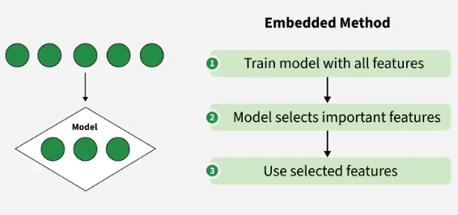
Embedded methods perform feature selection during the model training process. They combine the benefits of both filter and wrapper methods. Feature selection is integrated into the model training allowing the model to select the most relevant features based on the training process dynamically.
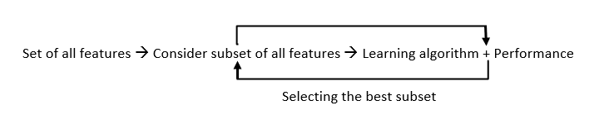
Advantages:
- More efficient than wrapper methods because the feature selection process is embedded within model training.
- Often more scalable than wrapper methods.
Limitations: Works with a specific learning algorithm so the feature selection might not work well with other models
Some techniques used are:
- L1 Regularization (Lasso): A regression method that applies L1 regularization to encourage sparsity in the model. Features with non-zero coefficients are considered important.
- Decision Trees and Random Forests: These algorithms naturally perform feature selection by selecting the most important features for splitting nodes based on criteria like Gini impurity or information gain.
- Gradient Boosting: Like random forests gradient boosting models select important features while building trees by prioritizing features that reduce error the most.
Choosing the Right Feature Selection Method
Choice of feature selection method depends on several factors:
- Dataset Size: Filter methods are often preferred for very large datasets due to their speed.
- Feature Interactions: Wrapper and embedded methods are better for capturing complex feature interactions.
- Model Type: Some methods like Lasso and decision trees are more suitable for certain models like linear models or tree-based models.
With these feature selection methods we can easily improve performance of our model and reduce its computational cost.

What is Feature Extraction?
Feature extraction is an important technique used in machine learning and data analysis to transform raw data into a set of features that are easier for algorithms to work with. By reducing the complexity of the data, it keeps only the important parts and discards the unnecessary details. This allows machines to process data more efficiently and helps improve the accuracy of models. In many fields like image processing, natural language processing and signal processing, raw data often comes with multiple characteristics. Many of these might be redundant or irrelevant. Feature extraction helps simplify this data, retaining only the most useful information for analysis. In this article we will see more about feature extraction, its importance and other core concepts.

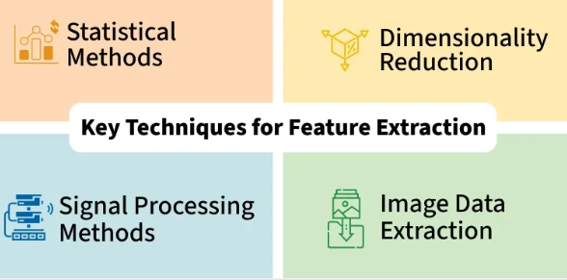

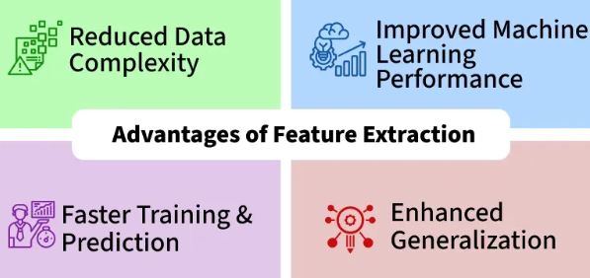

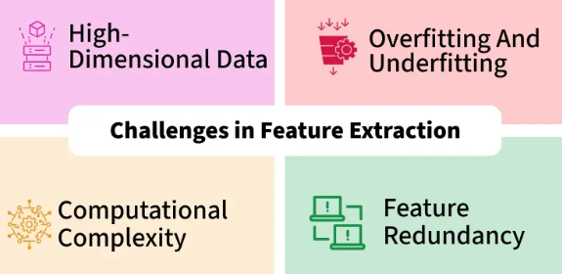

Why is Feature Extraction Important?
Feature extraction is important for several reasons:
- Reduced Computation Cost: Raw data, especially from images or large datasets can be very complex. Feature extraction makes this data simpler, reducing the computational resources needed for processing.
- Improved Model Performance: By focusing on key features, machine learning models can work with more relevant information, leading to better performance and more accurate results.
- Better Insights: Reducing the number of features helps algorithms concentrate on the most important data, eliminating noise and irrelevant information which can lead to deeper insights.
- Prevention of Overfitting: Models with too many features may become too specific to the training data, making them perform poorly on new data. Feature extraction reduces this risk by simplifying the model.
- Key Techniques for Feature Extraction
There are various techniques for extracting meaningful features from different types of data:

- Statistical Methods

Statistical methods are used in feature extraction to summarize and explain patterns of data. Common data attributes include:

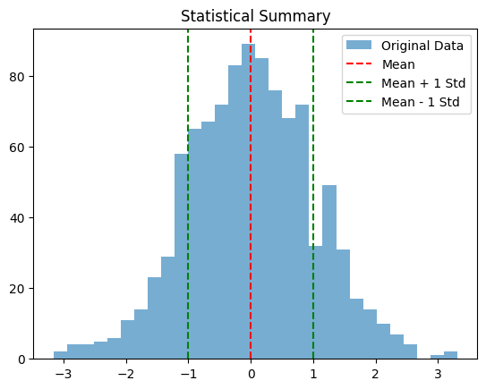
Statistical Methods
- Mean: The average value of a dataset.
- Median: The middle value when it is sorted in ascending order.
- Standard Deviation: A measure of the spread or dispersion of a sample.
- Correlation and Covariance: Measures of the linear relationship between two or more factors.
- Regression Analysis: A way to model the link between a dependent variable and one or more independent factors.
These statistical methods can be used to represent the center trend, spread and links within a collection.

- Dimensionality Reduction
Dimensionality reduction reduces the number of features without losing important information. Some popular methods are:

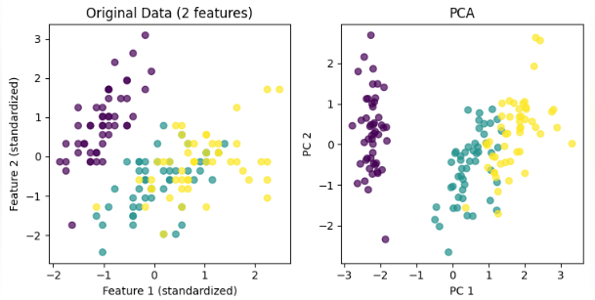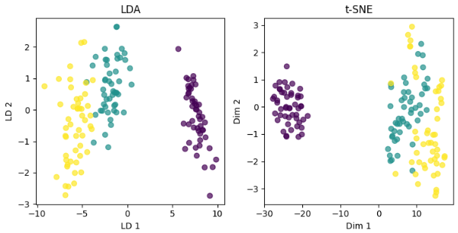
- Principal Component Analysis: It selects variables that account for most of the data’s variation, simplifying the dataset by focusing on the most important components.
- Linear Discriminant Analysis (LDA): It finds the best combination of features to separate different classes, maximizing class separability for better classification.
- t-Distributed Stochastic Neighbor Embedding (t-SNE): A technique that reduces high-dimensional data into two or three dimensions ideal for visualizing complex datasets.
- Feature Extraction for Textual Data
In Natural Language Processing (NLP), we often convert raw text into a format that machine learning models can understand. Some common techniques are:
- Bag of Words (BoW): Represents a document by counting word frequencies, ignoring word order, useful for basic text classification.
- Term Frequency-Inverse Document Frequency (TF-IDF): Adjusts word importance based on frequency in a specific document compared to all documents, highlighting unique terms.
- Signal Processing Methods
It is used for analyzing time-series, audio and sensor data:
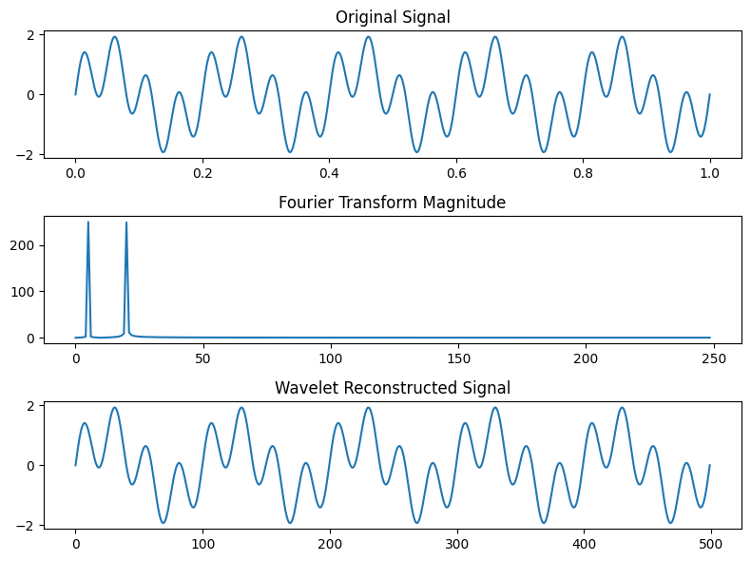Signal processing methods
- Fourier Transform:It converts a signal from the time domain to the frequency domain to analyze its frequency components.
- Wavelet Transform:It analyzes signals that vary over time, offering both time and frequency information for non-stationary signals.
Image Data Extraction
Techniques for extracting features from images:
Image Data Extraction
- Histogram of Oriented Gradients (HOG):This technique finds the distribution of intensity gradients or edge directions in an image. It's used in object detection and recognition tasks.
- Convolutional Neural Networks (CNN) Features: They learn hierarchical features from images through layers of convolutions, ideal for classification and detection tasks.
Choosing the Right Method
Selecting the appropriate feature extraction method depends on the type of data and the specific problem we're solving. It requires careful consideration and often domain expertise.
- Information Loss: Feature extraction might simplify the data too much, potentially losing important information in the process.
- Computational Complexity: Some methods, especially for large datasets can be computationally expensive and may require significant resources.
Feature Selection vs. Feature Extraction
Since Feature Selection and Feature Extraction are related but not the same, let’s quickly see the key differences between them for a better understanding:
Aspect | Feature Selection | Feature Extraction
Definition | Selecting a subset of relevant features from the original set | Transforming the original features into a new set of features
Purpose | Reduce dimensionality | Transform data into a more manageable or informative representation
Process | Filtering, wrapper methods, embedded methods | Signal processing, statistical techniques, transformation algorithms
Output | Subset of selected features | New set of transformed features
Computational Cost | Lower cost | May be higher, especially for complex transformations
Interpretability | Retains interpretability of original features | May lose interpretability depending on transformation
Applications of Feature Extraction
Feature extraction plays an important role in various fields where data analysis is important. Some common applications include:
1. Image Processing and Computer Vision:
- Object Recognition: Extracting features from images to recognize objects or patterns within them.
- Facial Recognition: Identifying faces in images or videos by extracting facial features.
- Image Classification: Using extracted features for categorizing images into different classes or groups.
2. Natural Language Processing (NLP):
- Text Classification: Extracting features from textual data to classify documents or texts into categories.
- Sentiment Analysis: Identifying sentiment or emotions expressed in text by extracting relevant features.
- Speech Recognition: Identifying relevant features from speech signals for recognizing spoken words or phrases.
3. Biomedical Engineering:
- Medical Image Analysis: Extracting features from medical images (like MRI or CT scans) to assist in diagnosis or medical research.
- Biological Signal Processing: Analyzing biological signals (such as EEG or ECG) by extracting relevant features for medical diagnosis or monitoring.
- Machine Condition Monitoring: Extracting features from sensor data to monitor the condition of machines and predict failures before they occur.
Tools and Libraries for Feature Extraction
There are several tools and libraries available for feature extraction across different domains. Let's see some popular ones:
- Scikit-learn: It offers tools for various machine learning tasks including PCA, ICA and preprocessing methods for feature extraction.
- OpenCV: A popular computer vision library with functions for image feature extraction such as SIFT, SURF and ORB.
- TensorFlow / Keras: These deep learning libraries in Python provide APIs for building and training neural networks which can be used for feature extraction from image, text and other types of data.
- PyTorch: A deep learning library enabling custom neural network designs for feature extraction and other tasks.
- NLTK (Natural Language Toolkit): A popular NLP library providing feature extraction methods like bag-of-words, TF-IDF and word embeddings for text data.
Advantages of Feature Extraction
Feature extraction has various advantages which are as follows:
- Reduced Data Complexity: Condenses complex datasets into a simpler form, making data easier to analyze and visualize like turning a cluttered room into a well-organized space.
- Improved Machine Learning Performance: By removing irrelevant data, it allows algorithms to work more efficiently, leading to faster processing and better accuracy.
- Simplified Data Analysis: Extracts the most important features, filtering out noise, allowing for quicker identification of key patterns.
- Enhanced Generalization: It helps the model focus on the most informative features which leads to better performance when applied to new, unseen data.
- Faster Training and Prediction: By reducing the number of features, it speeds up both the training phase and real-time predictions, making model deployment faster and more efficient, especially with large datasets.
Challenges in Feature Extraction
- Handling High-Dimensional Data: As datasets grow in size and complexity, it becomes challenging to extract relevant features without overwhelming the model with unnecessary information.
- Overfitting and Underfitting: If too few or too many features are extracted, models can either overfit or underfit affecting their generalization ability.
- Computational Complexity: Some feature extraction methods, especially those with complex transformations, require significant computational resources, making them impractical for large datasets or real-time applications.
- Feature Redundancy and Irrelevance: Extracted features may overlap or include irrelevant data which can confuse the model and reduce overall performance, leading to inefficiency.
By mastering feature extraction, we can make our data more useful, improve model performance and overcome common challenges to achieve better results.

Singular Value Decomposition:
From Chat GPT
Singular Value Decomposition (SVD) is a fundamental matrix factorization technique used in linear algebra, statistics, signal processing, machine learning, and many other fields.

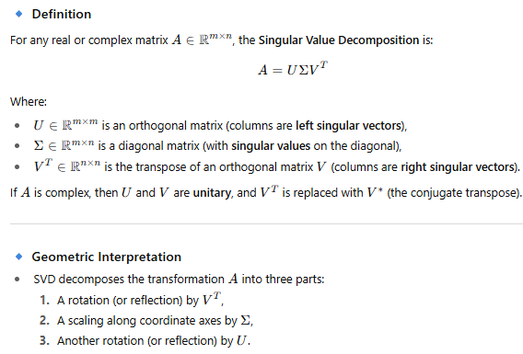
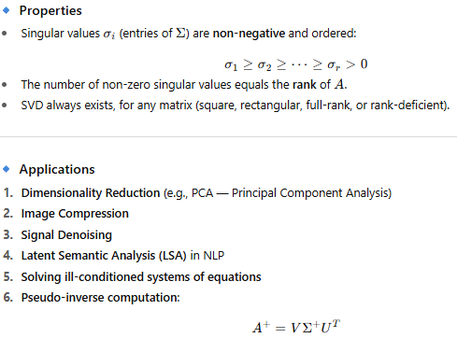
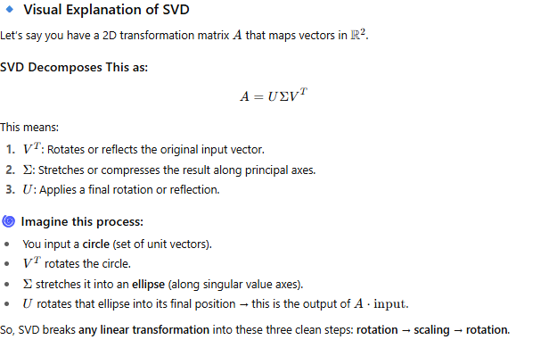

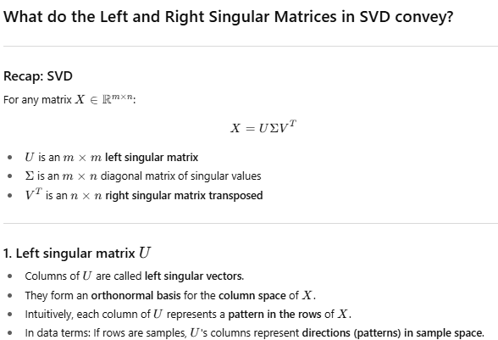
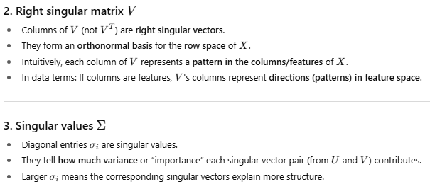
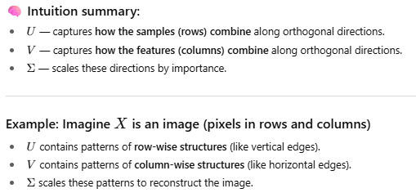

Here are some other cool applications of SVD beyond image compression — with brief explanations and how SVD fits into them:
Dimensionality Reduction / Principal Component Analysis (PCA)
- Use: Reduce the number of features in a dataset while preserving most of the variance.
- How SVD fits: PCA can be performed by computing the SVD of the data matrix (centered). The top singular vectors correspond to principal components.
- Why it’s cool: Helps visualize high-dimensional data, speeds up machine learning, removes noise.
Latent Semantic Analysis (LSA) / Topic Modeling in NLP
- Use: Extract hidden semantic topics from a large document-term matrix.
- How SVD fits: Decompose the large sparse matrix into lower-rank approximations capturing concepts/topics.
- Why it’s cool: Enables understanding of underlying themes in texts, search engines, document clustering.
Recommender Systems (Collaborative Filtering)
- Use: Predict user preferences (like movie ratings) based on past behavior.
- How SVD fits: Factorize user-item rating matrix into latent user and item features to estimate missing ratings.
- Why it’s cool: Powers Netflix, Amazon, Spotify recommendations by uncovering hidden patterns.
Noise Reduction in Signals and Images
- Use: Separate signal from noise by truncating small singular values.
- How SVD fits: Noise corresponds to small singular values; discarding them cleans data.
- Why it’s cool: Improves quality in audio, images, medical signals.
Solving Linear Systems / Pseudo-Inverse
- Use: Solve systems of linear equations, especially when matrix is not invertible or is ill-conditioned.
- How SVD fits: Compute Moore-Penrose pseudo-inverse using SVD to find least-squares solutions.
- Why it’s cool: More stable and accurate than other methods.
Face Recognition
- Use: Represent faces efficiently for matching and classification.
- How SVD fits: Use “eigenfaces” (singular vectors) as features for faces.
- Why it’s cool: Early computer vision breakthrough for biometric systems.

How to compute Explained Variance from SVD components
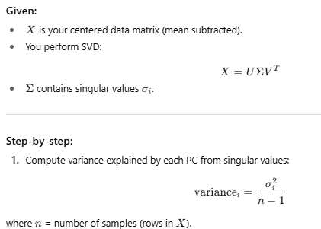
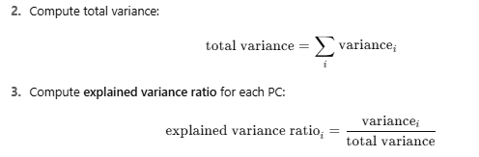

Principal component Analysis
After doing PCA, what is your Goal. If your goal is one of the below, then the corresponding Next Step is given.

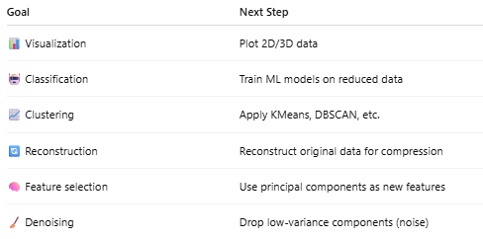

Linear Discriminant Analysis (LDA)
It is a powerful technique for both dimensionality reduction and classification — especially when you have labeled data.
What is LDA?
- LDA finds a projection that maximizes class separability.
- Unlike PCA (which is unsupervised and focuses on maximizing variance), LDA uses labels to find axes that best separate classes.
- It tries to maximize between-class variance while minimizing within-class variance.
- Often used in supervised classification and feature extraction.
- LDA vs PCA — quick comparison:
Aspect | PCA | LDA
Supervision | Unsupervised | Supervised
Goal | Maximize variance | Maximize class separability
Number of components | Up to min(n_samples, n_features) | Up to (number of classes - 1)
Use case | Dimensionality reduction, visualization | Dimensionality reduction for classification

Step-by-Step LDA Math Breakdown
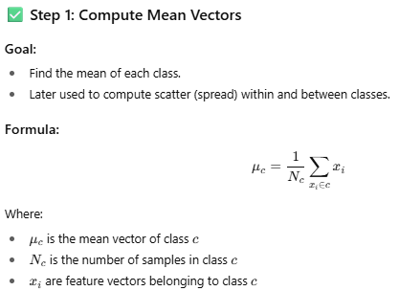
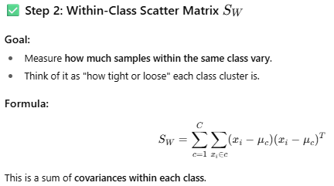
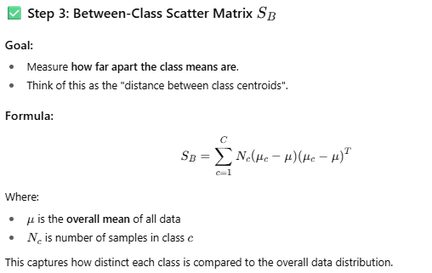
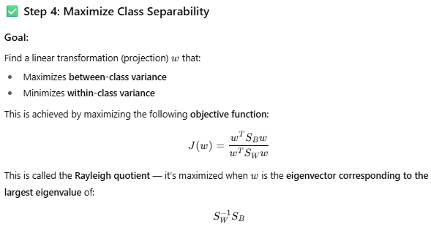
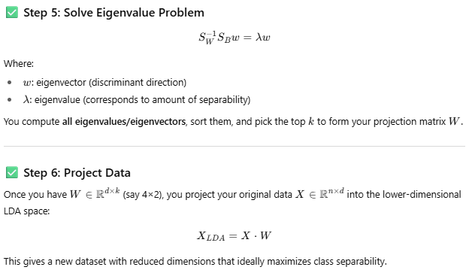
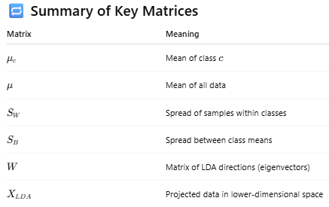
When is LDA most effective?
- When classes are linearly separable
- When class distributions are Gaussian with equal covariances
- When you want supervised dimensionality reduction

how Linear Discriminant Analysis (LDA) naturally extends to multiclass classification — both conceptually and mathematically.
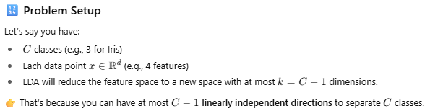
Key Idea
The goal of multiclass LDA is the same as in binary LDA:
Find projection directions that maximize the distance between class means while minimizing the scatter within each class.
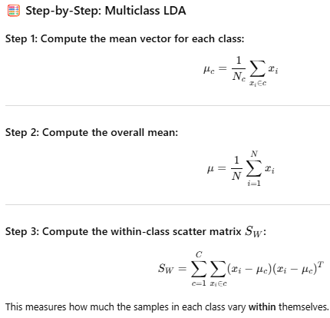
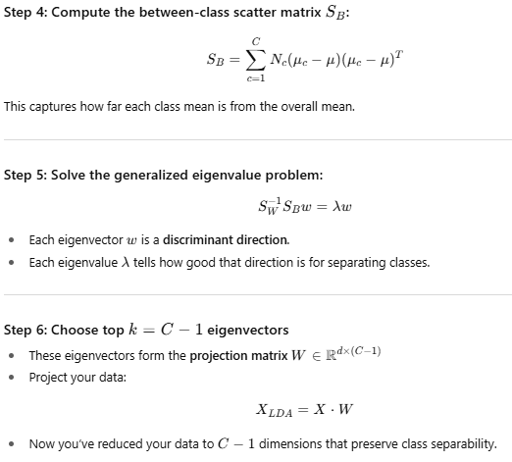
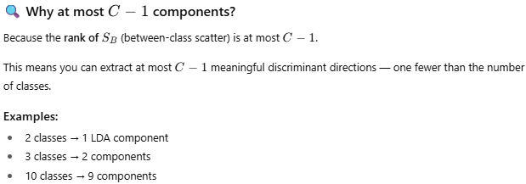

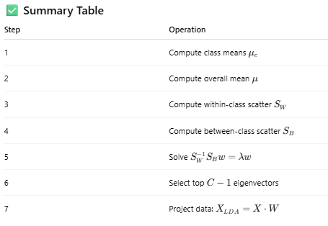

That LinAlgError:
Singular matrix means your within-class scatter matrix SWS_WSW​ is singular (non-invertible), which is common when:
- You have high-dimensional data but not enough samples (e.g., features > samples per class).
- Some features are linearly dependent or redundant.
- The data is not full rank in some classes.

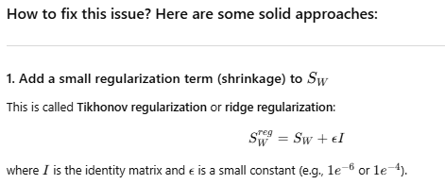
2. Reduce dimensionality first using PCA
- Apply PCA first to reduce dimensions, remove redundancies, then apply LDA.
- This is a common pipeline in high-dimensional datasets (e.g., images).

3. Check your data
- Make sure you have enough samples per class.
- Remove redundant or highly correlated features.
4. Use scikit-learn's LDA (LinearDiscriminantAnalysis) as fallback
- It has internal regularization and numerical stability.
- It can give you a baseline before manual implementation.

t-Distributed Stochastic Neighbor Embedding (t-SNE) —
a powerful nonlinear dimensionality reduction technique, especially popular for visualizing high-dimensional data in 2D or 3D!

What is t-SNE?
- Developed by Laurens van der Maaten and Geoffrey Hinton in 2008.
- Converts similarities between data points to joint probabilities.
- Minimizes the difference between these joint probabilities in high-dimensional and low-dimensional spaces using Kullback–Leibler divergence.
- Emphasizes preserving local structure — points close in high-dim space remain close in low-dim.
- Great for visual exploration of complex datasets (images, text embeddings, etc.).

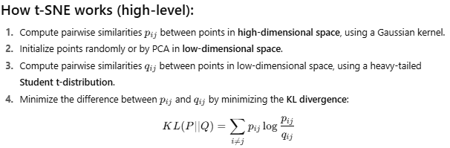
When to use t-SNE?
- When you want to visualize high-dimensional data in 2D or 3D.
- Great for exploratory data analysis, clusters, and manifold learning.
- Works well with image features, word embeddings, gene expression data, etc.
- Not ideal for very large datasets without subsampling or optimized implementations.

Let’s dive into the math behind t-Distributed Stochastic Neighbor Embedding (t-SNE) — it’s a fascinating technique combining probability distributions and information theory to embed high-dimensional data into a low-dimensional space.
1. Goal of t-SNE
- Preserve local structure of data points.
- Points close in high-dimensional space should stay close in low-dimensional embedding.
- Unlike PCA (linear), t-SNE captures nonlinear relationships.

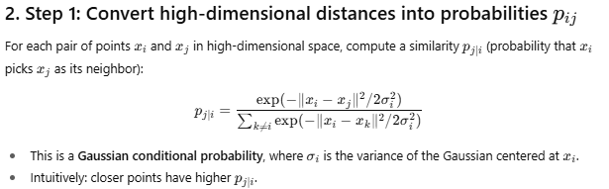
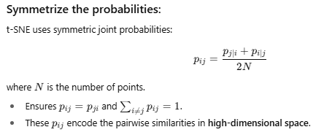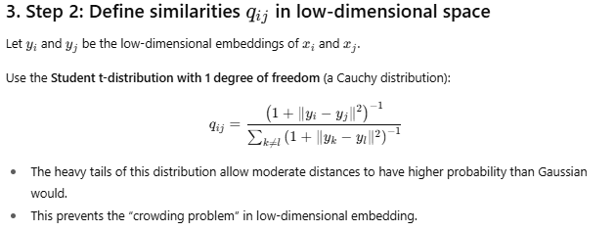
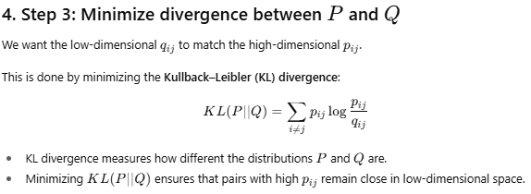
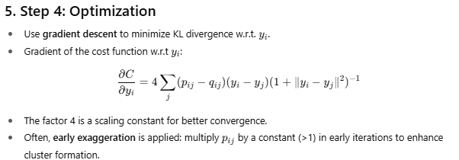
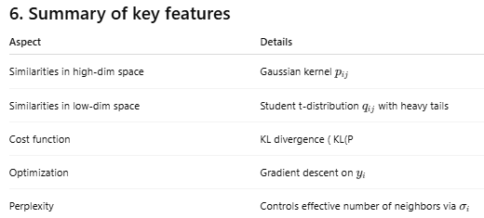

Let’s talk about the two most important t-SNE hyperparameters:
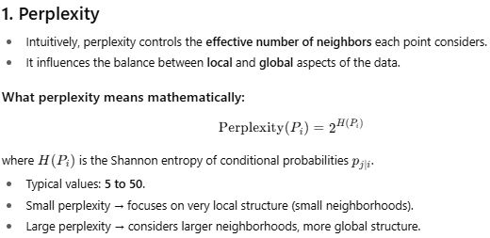

How to tune perplexity:
- Try multiple values (e.g., 5, 10, 30, 50).
- Low values may cause fragmented clusters.
- High values may cause loss of local detail.
- The best perplexity depends on dataset size: bigger datasets usually tolerate larger perplexity.

2. Learning Rate (also called learning_rate or early_exaggeration parameter)
- Controls the step size of gradient descent.
- If learning rate is too low → slow convergence or stuck in bad local minima.
- If too high → can cause divergence or noisy embeddings.
Typical values:
- Default in sklearn: 200
- Good range: 10 to 1000
Tuning tips:
- If t-SNE output is clumped together or points overlap, try increasing the learning rate.
- If output looks scattered or noisy, try lowering the learning rate.

3. Optional: Number of Iterations
- Default is often 1000.
- More iterations → better convergence but longer runtime.
- Early exaggeration (usually first 250 iterations) improves cluster formation.

Linear Techniques
- Principal Component Analysis (PCA)
  - Projects data onto directions maximizing variance.
  - Linear, unsupervised.
- Linear Discriminant Analysis (LDA)
  - Projects data to maximize class separability.
  - Supervised, linear.
- Singular Value Decomposition (SVD)
  - Matrix factorization used in PCA and other methods.
- Factor Analysis
  - Models observed variables as linear combinations of latent factors.
- Independent Component Analysis (ICA)
  - Finds components that are statistically independent.

Nonlinear / Manifold Learning Techniques
- t-Distributed Stochastic Neighbor Embedding (t-SNE)
  - Preserves local neighborhoods; nonlinear, good for visualization.
- Isomap
  - Preserves geodesic distances on manifold; nonlinear.
- Locally Linear Embedding (LLE)
  - Preserves local linear relationships.
- Multidimensional Scaling (MDS)
  - Preserves pairwise distances.
- Kernel PCA
  - PCA in a transformed (kernel) feature space; captures nonlinearities.
- Autoencoders
  - Neural network based nonlinear dimensionality reduction.
- UMAP (Uniform Manifold Approximation and Projection)
  - Preserves both local and global data structure; faster alternative to t-SNE.
- Self-Organizing Maps (SOM)
  - Neural network based technique that produces a low-dimensional grid.
Others
- Random Projection
  - Projects data to lower dimension using random matrices, preserving distances approximately.
- Non-negative Matrix Factorization (NMF)
  - Factorizes data into non-negative components, useful for parts-based representations.

